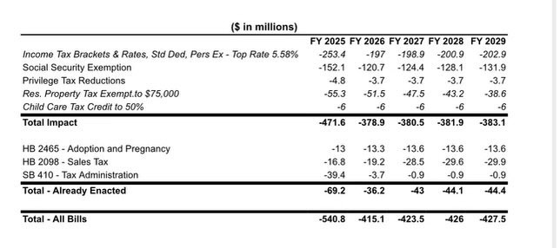
Special Session Tax Plan
- Two tiers: 5.2% and 5.58%
  - $23,000 and $46,000 income thresholds
- Standard deductions from SB 37
  - Standard deduction for single filers: $3,605
  - Standard deduction for married, filing jointly: $8,240
  - Standard deduction for head of household filing: $6,180
- Personal exemptions from SB 37
  - $18,320 for married couples filing jointly
  - $9,160 for all other filers
    - An additional $2,320 for each independent listed on the return
- Full elimination of Social Security
- Childcare funding at 50%
- Bankers’ piece included
- Residential exemption at $75,000
- 20 mills
- No acceleration of “axe the food tax”
  - Takes effect on January 1, 2025, as planned
- No LAVTRF funding
  - LAVTRF will not be repealed

